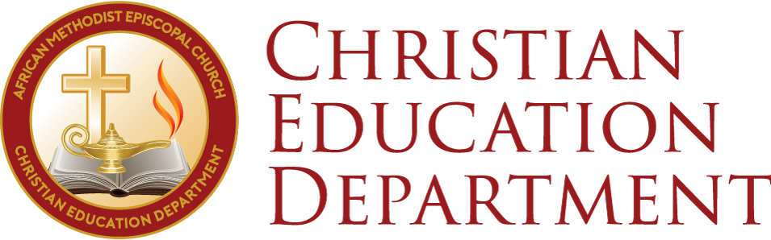

Some Devotional and Study Ideas During This Time of the Coronavirus Pandemic

Many are rightly concerned about this global Coronavirus Pandemic. With each news update and social media post, anxiety levels rise. Many church leaders have opted or have been mandated by civil authorities to refrain from the physical gathering of people for worship services and other regular church activities such as Church School, Bible study, organizational meetings, etc., in hopes that social distancing will help to reduce the spread of the disease and protect particularly the most vulnerable in the community. The Council of Bishops has issued a statement related to the pandemic and the various responses of our local congregations and communities. Some congregations will gather and worship online using the various technological and social media platforms (Facebook Live, Google Hangouts Meet, Zoom Video Conference (https://zoom.us), GoTo Meeting (https://www.gotomeeting.com/), to name a few.)

The Christian Recorder reports, “Google is making the professional version of Google Hangouts Meet available for FREE. This is a great tool to livestream services and studies.
Here are instructions for setting up streaming: https://support.google.com/meet/answer/9308630?fbclid=IwAR00qLiJnNy22lLAkOdHJS-bxHugieR6ENIUQRHNsd-pZbHCqD_LxTgiHkg
Don’t overpay for new services; you should be able to use Hangouts, Zoom, etc. for free or relatively low cost.”

We are people of faith! Even more now than ever, we must keep the faith and nurture it in ourselves and in others. Here are a few suggestions for devotional and study time during this period:
- Study individually or as a family/household/congregation the Church School lesson. It’s perhaps “old school”; but, it is a tried and tested way to nurture your faith through the reading and studying of God’s word.
Lesson for March 15, 2020 from the Spring Uniform Series Outlines. Psalm 37, Habakkuk 2
UNIFYING PRINCIPLE: People seem not to suffer for their unjust actions. When will acts of the unjust be punished? The psalmist affirms that God will reward the just, and Habakkuk declares that the unjust will be punished for wickedness.
- What is Habakkuk saying about the justice and benevolence of God?
- How does Habakkuk's understanding of God confuse or support our pastoral response in light of the coronavirus epidemic?
from In Real Time (CUS, National Council of Churches, USA)

The AMEC Publishing House will make the lessons for the next few weeks available as free PDF downloads.

- Use the 2020 Liberation and Unity Lenten Devotional produced by the Christian Education Departments of the AME, AMEZ, and CME Churches as a resource for your personal or collective time of devotion. It is based on the Home Daily Bible Readings of CUS that support the theme for the upcoming Church School Lesson. It can be found at: https://www.amazon.com/dp/B085424G9B/ref=sr_1_1?keywords=Liberation%20and%20Unity&qid=1582584976&sr=8-1&fbclid=IwAR29NvUShuHZDRJku__Nqt7vdTYfWyy_Llkp7CJgg7C2gxqYeaUjv7O8G_E

- Use the Daily Spiritual Vitamins produced by the Department as a free resource for your personal or collective time of devotion. They too are based on the Home Daily Bible Readings. They arrive daily via email, Twitter, and the Department’s webpage (https://ameced.com/daily-vitamin/) and Facebook page.

- Use the worship resources produced by the AMEC Publishing House as free resources for your personal or collective time of devotion. They are topical as well as based on the liturgical seasons: http://www.iamame.org/worship-resources/

The Christian Education Department, AMEC Publishing House, and others will continue to develop resources that can be used as times of personal and collective devotion and study during this pandemic to help us all sustain and strengthen our faith and resolve.

